

How to measure for cabinets

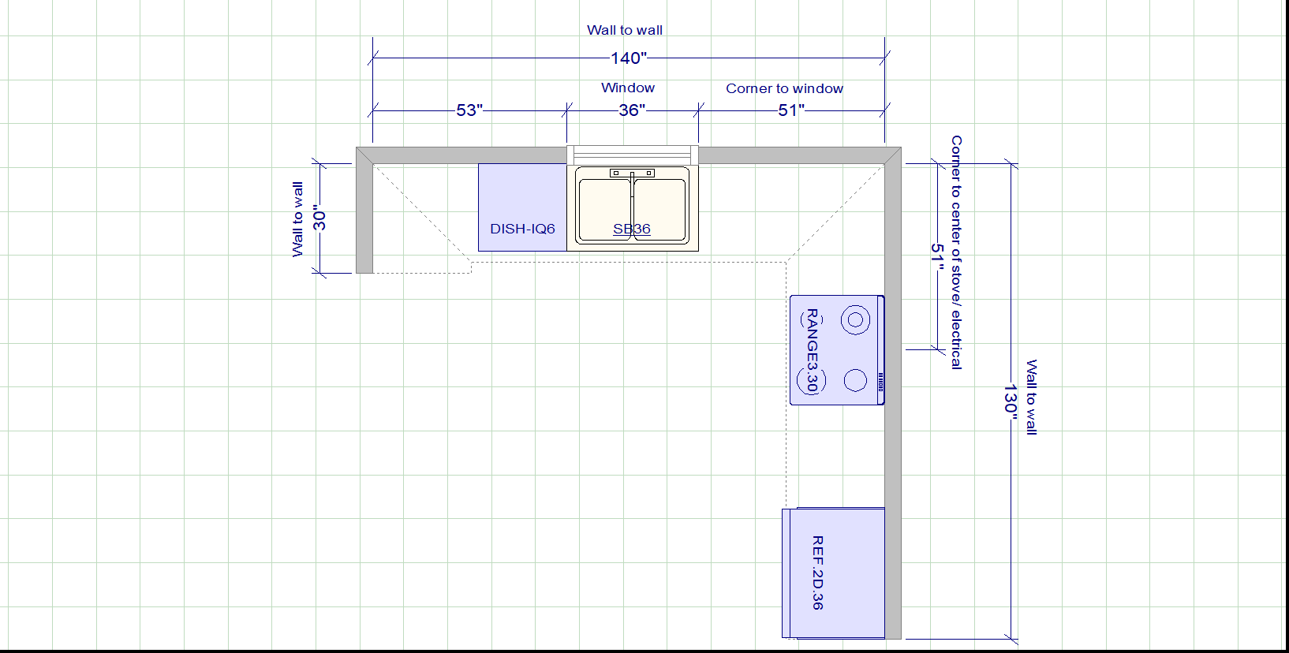

Directions:

1. Draw your walls out just like the example above. Measuring length & height of all walls needing cabinetry
2. Measurements of all windows, doorways, pass through or any obstructions
3. Dimensions of all appliance are necessary (Fridge, stove/cooktop, microwave, dishwasher etc.)
4. Sink Dimensions and style (drop-in, undermount, farmhouse etc.)